
3399 Winton Road South
Rochester, NY 14623

How to Get Started:

In order to participate in CP Rochester Respite Recreation programs, individuals must:
- Have Medicaid
- Enroll in the HCBS waiver
- Complete intake process for CP Rochester (instructions ↓)
- Receive approval for the service from CP Rochester and DDRO
- Participate in a Respite Recreation program annually
*Some programs may be available for private pay if an individual does not fit the criteria above*

Intake Process:

- Contact your Care Manager

- Complete a CP Rochester Intake Application for “Hourly Respite” services
- Submit completed application and required documentation to:

  - Laurie Gendron: lgendron@cprochester.org

- Obtain approval for Respite Recreation services
→You will receive a letter indicating the status of your approval →If approved, you may then proceed to registration

How to Register:

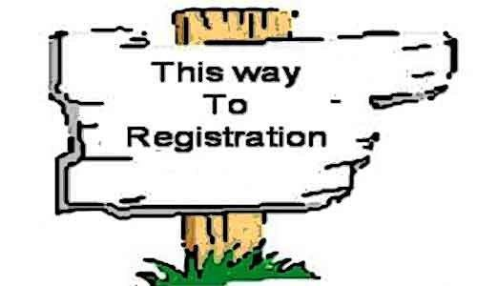
Visit our website to check out our current programs and events calendar Register on SportsNet website

Not enrolled in waiver services? Most recreation programs are available for private pay.
Rates are determined based on current Medicaid hourly rate. Department approval still required. Contact tpitner@cprochester.org for details.

Payment:

We try our best to offer low or no-cost recreation programs; however, some activities do require additional fees regardless of participant status. This fee applies to HCBS waiver enrolled, CAH waiver enrolled, and non-waiver enrolled participants.
Payments (when required) are due by the first day of the session.
*If payment is not received in time, your registration will be removed and spot will be opened to a member of the waitlist.
*You will receive an invoice via PayPal prior to the session.
Refund/Credits: In the event that a program or lesson is cancelled, we will issue a refund or credit to be applied towards future recreation programs.
*You will not receive a refund or credit for absences.
Reimbursement: Payment receipts will be provided and you may choose to submit your receipt for Family Reimbursement. *Please contact your Care Manager for further information.



Resources:

Want to stay in -the-know with CP Rochester Recreation AND SportsNet?
Join Our Distribution List!

Registration/Program Questions:
SportsNet Supervisor
tpitner@cprochester.org
SportsNet Lead Recreation Specialist
nventura@cprochester.org

CP Rochester Respite Intake: Laurie Gendron: lgendron@cprochester.org
Phone: 585-334-6000 x2281

